Bullet Time
“Bullet Time” will be used to create and emphasize player battlers in H2H.

Essentially it is a slow-motion effect combined with a speed-burst, so that the attacking player has a tool to help steal the flag.

Gameplay

The sequence of events goes something like this:

- Each player has a meter on their HUD that fills up over time
  - The meter gets an extra boost when you hit a breakable or movable physics object.
- When the meter is full the attacking player can initiate bullet time
  - Only the chaser can initiate it. So you can’t use it when you have the flag.
- The game slows down to slow motion (exact percentage of full speed to be tuned).
  - The transition in sim-rate is gradual from the game’s normal speed to slow-motion
  - The transition is accompanied by a stylized sound effect
- During slow-motion a HUD “fighter-jet style” target object will animate, letting the user know that a countdown is on. The length of this countdown is tunable, but is expected to be between 3-7 seconds. E.g.:
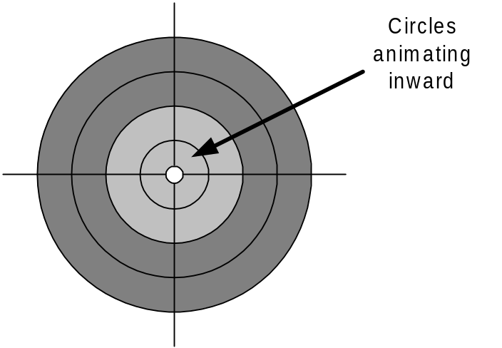
- Once the countdown is complete, the attacking player gets a speed burst (amount TBD) that will accelerate their vehicle, giving them a shot at the flag-carrier
- A couple seconds after the speed burst, bullet time reverts back to normal time (gradually and with a sound f/x)

Presentation

- Gradual transition in sim-rate from full speed to slow speed (and vice versa)
  - Sound effect accompanies transition in each direction (to and from full speed)
  - Music fades out during transition
- HUD power-meter pulses when full and the other player has the flag
- “Targeting” animated HUD object as a countdown timer, accompanied by an “electro-mechanical power build up” kind of sound f/x
- Speed-burst sound f/x

Tunables

- The transition time from normal speed to slow-motion (e.g., 0.5 seconds)
- The degree to which the game slows down (e.g., 25% of normal time)
- The duration of the countdown to speed-burst during slow-motion (3-5 seconds?)
- The amount of the speed burst (in KM/H?)
- The duration that slow-motion lasts after speed-burst has been fired

Screen Merge

This feature is to be investigated, and prototyped if is not overly complicated to do so:

- When bullet-time is initiated, the attacking player’s screen expands to full –screen (presentation/transition to be technically driven – in other words, whatever is most practical)
- This only takes place if the two players are “close enough” to both be seen on one screen
  - This “close enough” calculation has to take into account the relative velocity of both players (i.e., it might be a chase from behind, or a head-on encounter)
- A special “target camera” looks at both cars. There are a couple possibilities here:
  - A) The position of the camera doesn’t change (i.e., relative to the attacker’s car) but the target becomes the defending car
  - B) The camera picks a middle position between both cars and tries to show them both
- When bullet time ends (or if players get too far apart) the screens split again
- If this feature works well, we may also want to try disabling the ability to initiate bullet time when the cars are “too far apart”. This is definitely something to test out – it could be frustrating.

